Project Description

# Introduction:

This aim of this project is to design a watering system for home garden use. The targeted control unit is raspberry pi 3, the used programming language is LabVIEW.

# Requirements

Software:

Labview 2014

Makerhub LNIX

Hardware:

Raspberry Pi 3 (RPI)

Arduino UNO (ARD)

8 Modules Relay

Power Supply 12v,5v

Pump

4 Solenoid Valves

4 Humidity Sensors

I2C based Temp-Sensor

# Overview

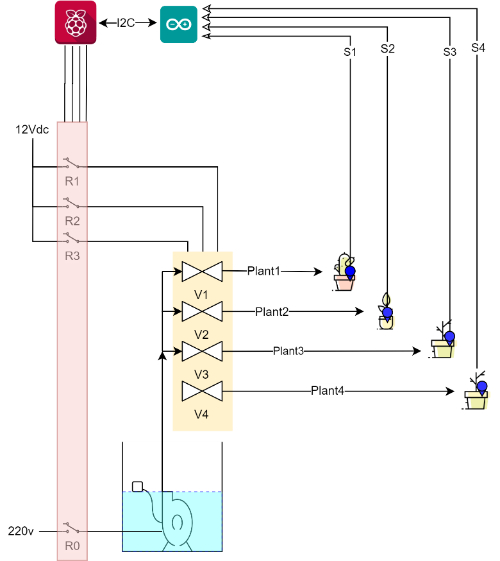The main program will run from the RPI. As shown in Figure 1. The RPI is responsible for turning on/off the relays which will turn on/off the pump and the 4 valves. The ARD will be used to read the humidity sensors from the soil and Transfer it to RPI for processing and logging.

Figure System overview

# LabVIEW code Structure

The Main VI will be programmed as shown in Figure 2:

* Initialization VI to create all the required references for Queues, User events, Paths and Device
* Startup VI to execute the write startup sequence.
* Two data-based producers for PC “accessed from LV front panel during software development” and PI “accessed from terminal”.
* Time-based producer to water the plants according to a predefined table “TimeTable”.
* Valve Control consumer loop, which control the pump and the valves.
* Time-based Temp Reading loop, frequently by a predefined interval measure the Temperature.

Init:

-Queues  
-User Events

-Paths

-Dev_REF

Startup

Data-based Producer “PC”

  
 Error  
 Handler

Data-based Producer “PI”

  
 Error  
 Handler

Time-based Event Producer

  
 Error  
 Handler

-Log start Time

-Log Temp.

Time-based Temp Reading

“AS6200”

  
 Error  
 Handler

-Log Watering.

Valve Control Consumer

  
 Error  
 Handler

Figure 2 System overview

# Files Tree

├── Consol

│ ├── Input Used to pass commands to PI-Based producer.

│ ├── Output Return error status after entering a command to Input.

│ ├── CH_Stat Return the output channels status.

│ ├── Timeout The next event is stored here.

│ └── TimeoutTable The daily event table is stored here.

├── Logs

│ ├── Error Error log file.

│ ├── StartTime Software start time log.

│ ├── Temp Temperature log.

│ └── WateringLog Watering log.

└── Settings

├── CFG.ini Initial settings.

├── Plant_Digital_OP Mapping of valves.

└── TimeTable Watering timetable.